**VIN Decoderz**

**Transport Trackers | 23.09.2023**

# Executive Summary

VIN Decoderz is a web-based tool that provides detailed information about a vehicle's history, specifications, and ownership based on its unique 17-character identifier. This information can include the vehicle's make, model, year, mileage, title status, accident history, and more. VIN Decoderz can be used by businesses and individuals to make informed decisions about buying, selling, or owning a vehicle.

This tool report provides a comprehensive overview of the installation, execution, scope, and limitations of the VIN Decoderz tool. The report also includes recommendations for how to use the tool effectively.

# Index

**Executive Summary 2**

**Index 2**

**1. Introduction 2**

**2. Tool Details 2**

**3. Installation 3**

**4. Execution 3**

**5. Scope and Limitations 3**

**6. Conclusion 3**

**7. References (if any) 4**

# Introduction

VIN Decoderz is a web-based tool that provides detailed information about a vehicle's history, specifications, and ownership based on its unique 17-character identifier. This information can include the vehicle's make, model, year, mileage, title status, accident history, and more. VIN Decoderz can be used by businesses and individuals to make informed decisions about buying, selling, or owning a vehicle.

VIN Decoderz aggregates data from a variety of sources, including government databases, to provide a comprehensive report on each vehicle. This report can be used to identify potential problems with a vehicle, such as a salvage title, odometer rollback, or outstanding recall. VIN Decoderz can also be used to verify the information that is provided by a vehicle seller.

# Tool Details

It is a web based tool.

Website: https://www.vindecoderz.com/

# Installation

**VIN Decoderz is a web-based tool, so there is no need to install any software. To use the tool, simply visit the VIN Decoderz website and enter the vehicle's VIN into the search bar.**

# Execution

To use the VIN Decoderz tool, simply enter the vehicle's VIN into the search bar on the VIN Decoderz website and click "Decode VIN." VIN Decoderz will then generate a report on the vehicle that includes information such as the vehicle's make, model, year, mileage, title status, accident history, and more.

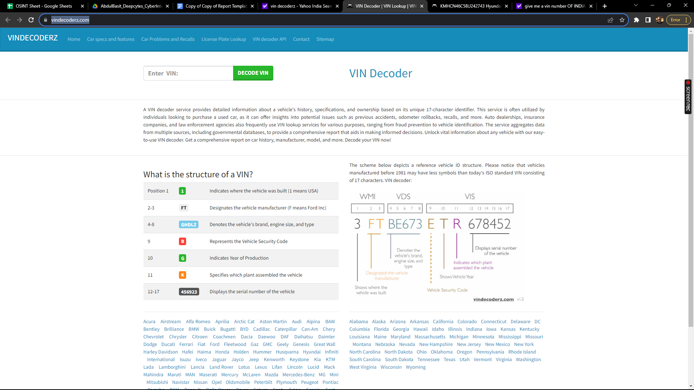

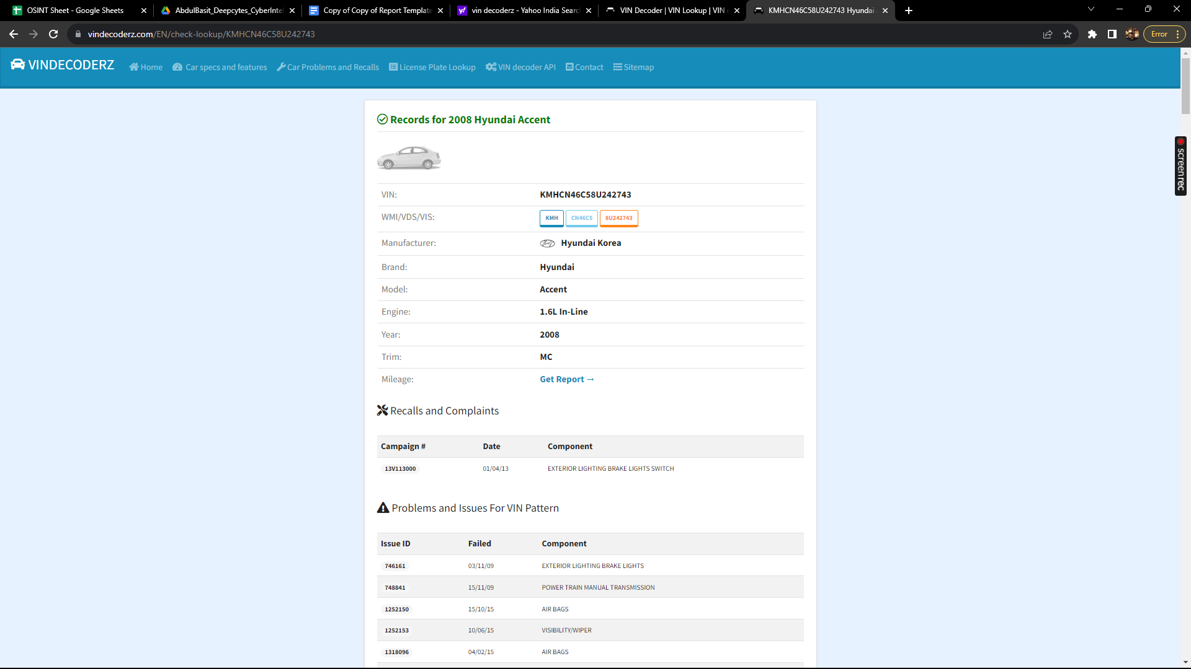

# Scope and Limitations

VIN Decoderz is a powerful tool for obtaining information about a vehicle's history, specifications, and ownership. However, it is important to be aware of the limitations of the tool.

VIN Decoderz can only provide information about vehicles that have a valid VIN. If the vehicle's VIN is invalid, VIN Decoderz will not be able to generate a report.

Additionally, VIN Decoderz cannot guarantee that the information that it provides is accurate or up-to-date. It is possible that the information that VIN Decoderz provides may be incorrect or out of date.

# Conclusion

VIN Decoderz is a valuable tool for businesses and individuals who want to make informed decisions about buying, selling, or owning a vehicle. The tool is easy to use and provides a variety of useful features. However, it is important to be aware of the limitations of the tool before using it.

Recommendations:

To use the VIN Decoderz tool effectively, it is important to understand its limitations. For example, VIN Decoderz can only provide information about vehicles that have a valid VIN. Additionally, VIN Decoderz cannot guarantee that the information that it provides is accurate or up-to-date.

It is also important to use VIN Decoderz in conjunction with other tools and services. For example, you could use VIN Decoderz to obtain a vehicle's history report, and then use a different tool to get a pre-purchase inspection.

Additionally, it is important to verify the information that is provided by VIN Decoderz with other sources. For example, you could check the vehicle's title status with the state's Department of Motor Vehicles.